Progress Report

Course number: IST 615

Name: Zeyang Zhou

Due date: April 19 / 2021

Submitted date: April 19 / 2021

**2 to 3 page document describing the tasks completed so far in your final project and any issues you have encountered.**

In my final project, there will be three parts. First, it is an introduction to sagemaker studio including history, development, and several functions like autopilot, autoexperiment. Second part may be the result.

What will be in my final report:

Outline:

1. Introduction

-What is sagemaker studio? --Done

-History and background of it. --Done

-List and explain the functions of it. --Continuing

-Cloud services used in it. –Done

1. Objectives  
   -- This part is about the goals in my proposal. –Done
2. Using sagemaker studio to do data analysis, deploy a machine learning model and display the results.

-- introduction of the dataset: videogames sales. –Done

-- Notebook instances, codes and model. --Continuing

-- Comparison: Show different results like the accuracy of different machine learning algorithms and the usages of sagemaker autoexperients. --Continuing

-- How to use sagemaker autopilot to do data analysis and find the most appropriate machine learning model automatically. –Continuing

1. Conclusion

-- Conclude the advantages and disadvantages of AWS machine learning services. –Continuing

1. References --Continuing

Exploration of sagemaker studio and I will explain the meanings of these icons in my final report —Done

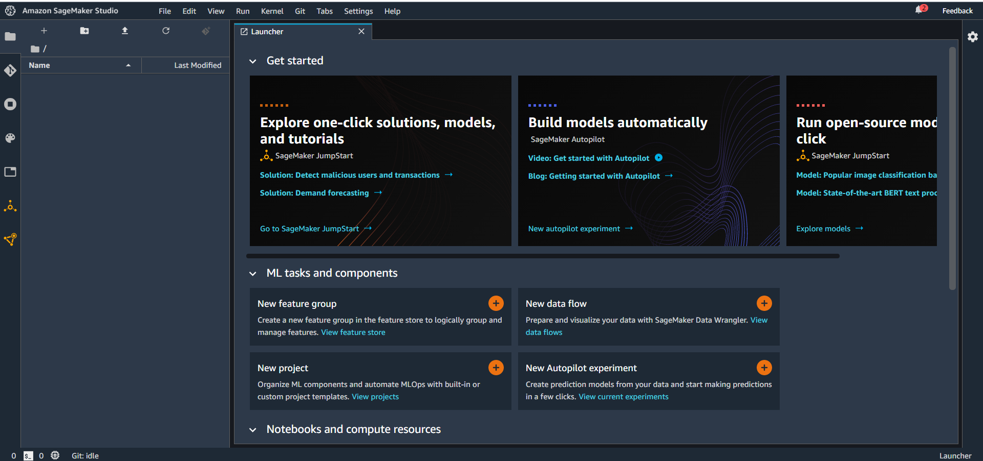

I create a test notebook instance which size is t2 medium. - Done

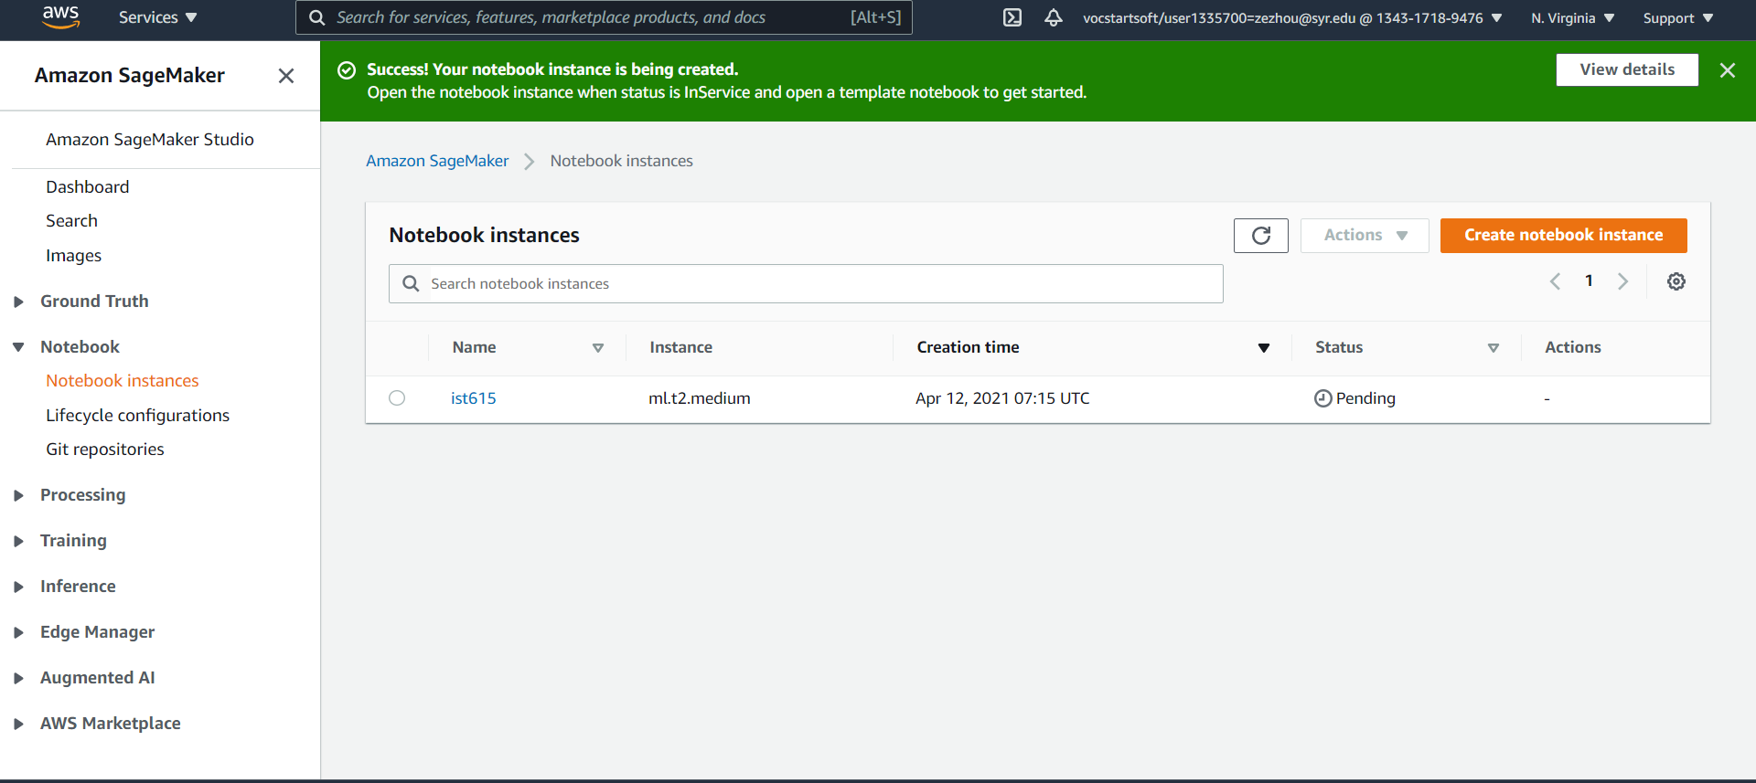

I am working on learning the examples provided by AWS Machine Learning. (KNN- Done.

SVM- Continuing)

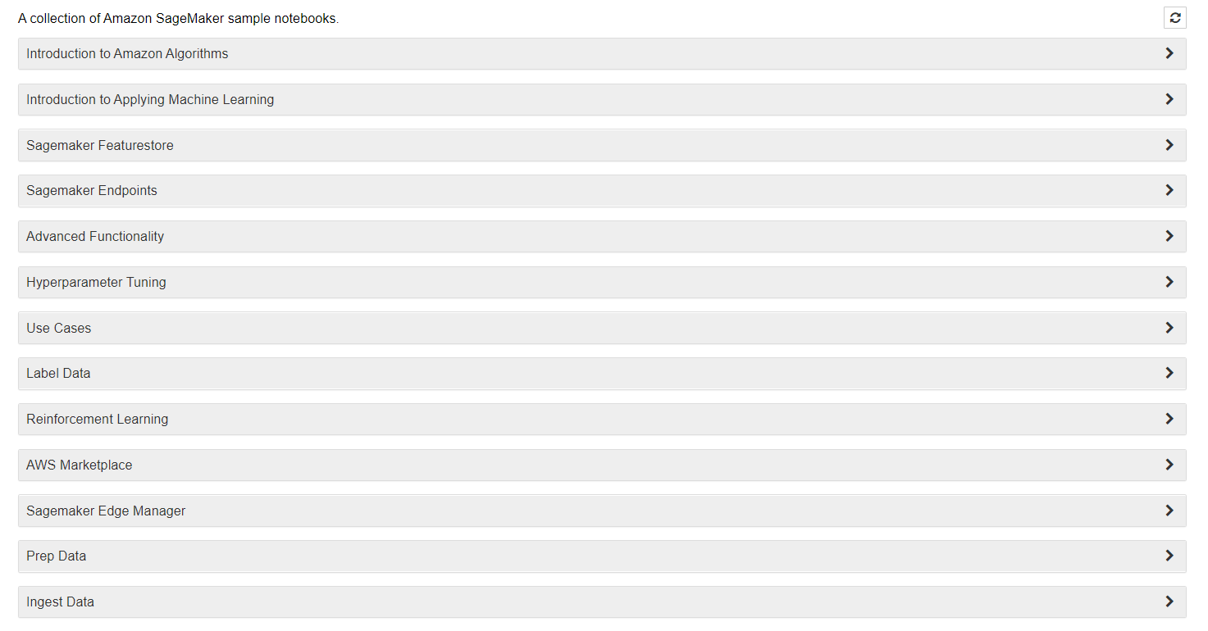

Try to complete a whole machine learning lifecycle in sagemaker studio including: prepare, build, train and deploy&tune.

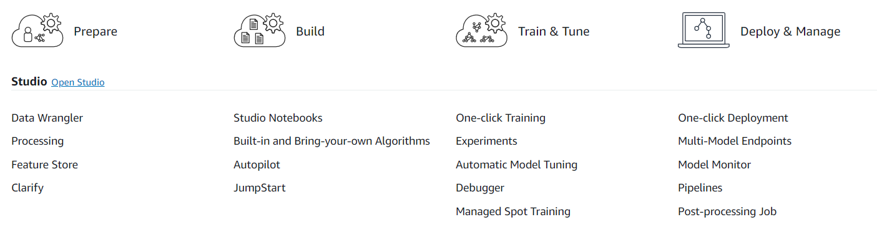

Atuopilot- 2MB dataset needs 2-5 hours.

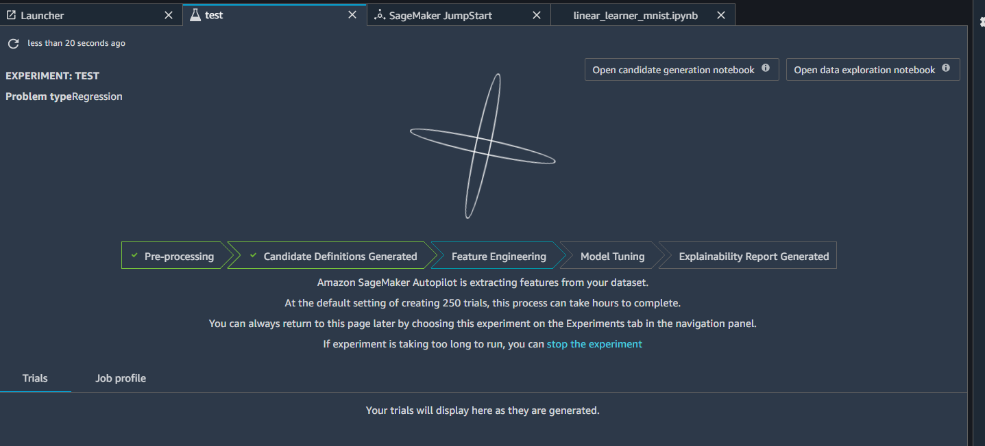

250 trials- default

Notebook instance: Jupyter notebook.

It can be done in sagemaker studio or I can just create a notebook instance out of sagemaker studio.

KNN demo AWS example kernel- python 2

Demo- video games sales: to predict popular games –xgboost-

A variant of Gradient Boosting Decision Tree. Kaltura

Slide

AutoExperience - continuing